**Annual cultural report 2023-24**

**Youth festival 2024**

Various competitions were held for the selection of the students to take part in the youth festival 2023-24 organised by Hemchand Yadav University at the college level in various art forms namely extempore, group discussion, mehendi competition, rangoli competition, painting, collage, poster making and quiz. Different colleges were selected as centres for the conduction of competitions and following is the list of students who took part:-

|  |  |  |
| --- | --- | --- |
| S.No. | Name of the art form | Name of the participants from the college |
| 1. | Extempore | Vinay Vasnik, B.A.I Sem |
| 2. | Group discussion (for) | Manish Kumar Tandekar, M.A. I Sem. Hindi |
| 3. | Group discussion (against) | Sahdev, M.A. I Sem. Hindi |
| 4. | Mehendi | Shraddha Sahu, B.Sc.I Sem. |
| 5. | Painting | Pumesh Kumar, B.A. III Sem. |
| 6. | Collage | Kuber, B.Sc.III Sem. |
| 7. | Poster making | Karuna Patil, B.Com. III year |
| 8. | Quiz | 1. Geetanjali Sahu, M.A. III Sem. Political Sc. 2. Surekha Sori, M.A.III Sem. Political Sc. 3. Rupali Sonwani, B.Lib. |
| 9. | Rangoli | Sameer Banjare, B.Sc. I Sem. Bio |

**A cultural program on the World disability day**

On 5th December, every year the world disability day is observed. This year too, on 5th December 2023, a cultural program was organised to motivate and support our specially abled students. Saraswati Vandana followed by patriotic songs, folk songs like panthi, seva geet, vidai geet were presented beautifully by our students. The specially abled students not only got praise for their talent in music but were presented with some prize money and stationery. Moreover, a room in the college was allotted to them for their music practice. Not only students but teachers too participated in their joy expressed by their beautiful songs sung by Dr. Neelu Shrivastav, Sharad Kumar Tiwari among many. The whole program was planned and successfully implemented by Dr. Anita Shankar, coordinator, cultural committee of the college.

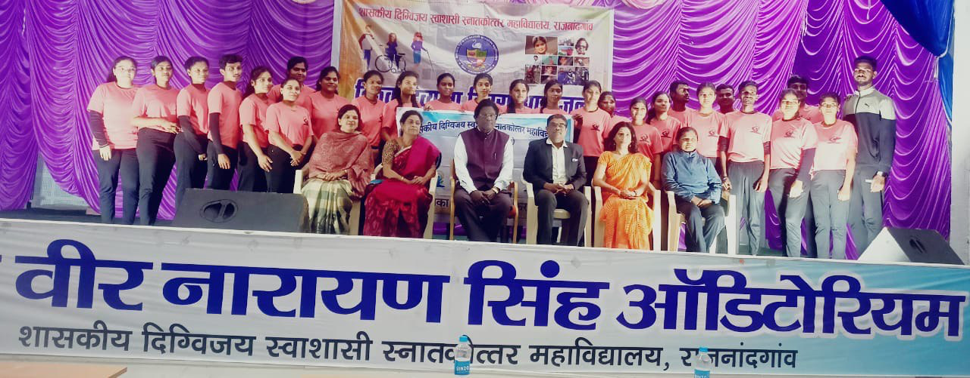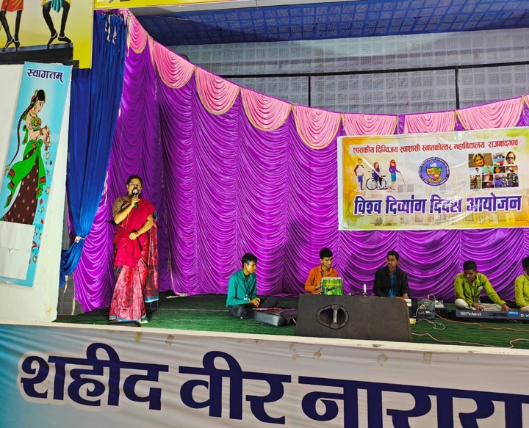

**“Utthan”- Youth Festival**

On December 15th 2023, a youth festival “Utthan” was organised by the Central Institute of Petrochemical Engineering and Training (CIPET), Raipur. A group of students performed Chhattisgarhi folk dance and it turned out to be a good exposure for the students. The students escorted by Mrs. Karuna Rawte, assistant professor, Zoology and Mr. Sharad Tiwari.

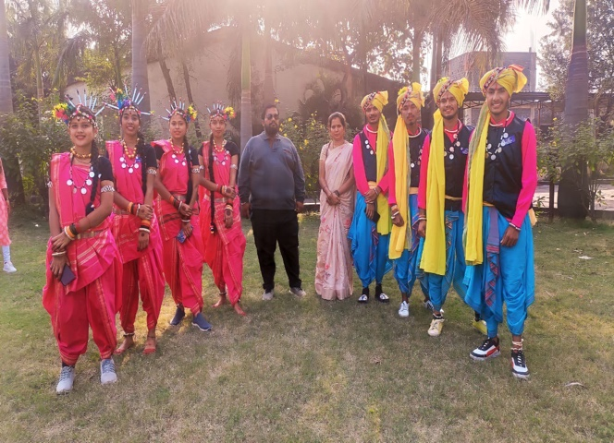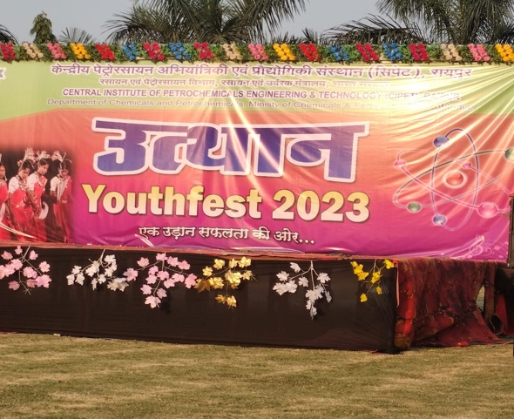

**Annual Cultural Meet 2024**

The annual cultural meet was organised on 10th of February 2024 in which the students participated in singing, dancing, mime, dramas and plays, programs celebrating the rich Indian cultural heritage with great pomp and show. Around 250 students participated in this year’s cultural festival. Although all the students gave their best but some just won the hearts of the audience and the

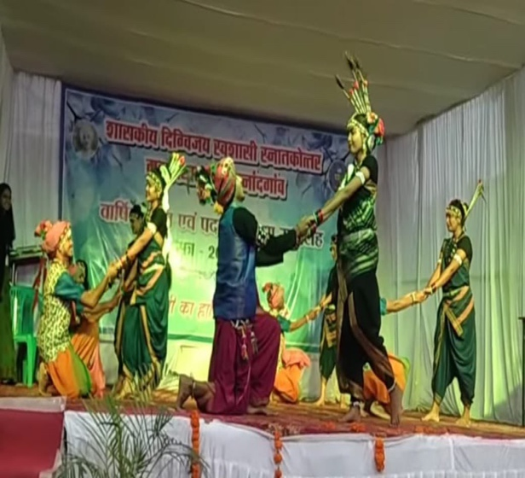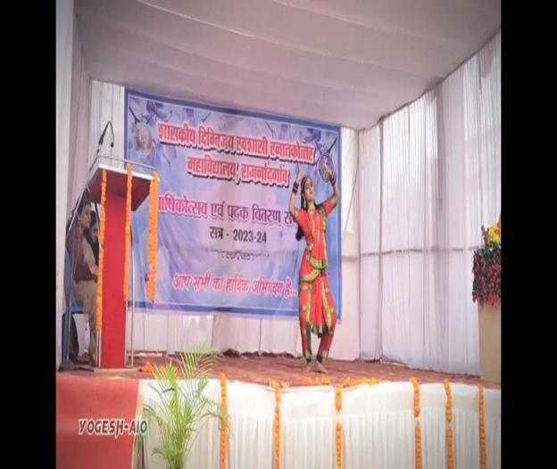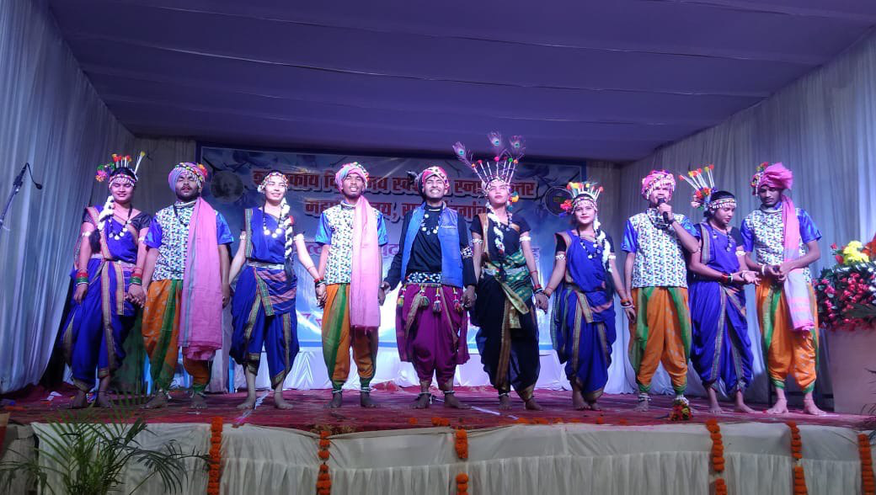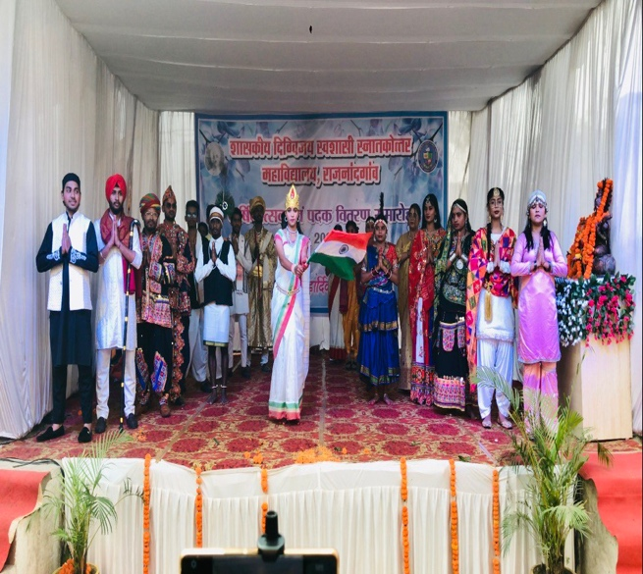

judges and were rightly selected for prizes by our prestigious judges, Mr. Hemant Nandagauri, assistant professor, Department of law, Chhattisgarh J. Yoganandam college, Raipur, Miss Rupali Pandey and Miss Surabhi Shrivastav. The anchors, Miss Vandana Mishra, assistant professor, department of chemistry and Miss Ishwari did their job beautifully. The whole program was completed successfully under the guidance of Dr. K.L.Tandekar, principal and Dr. Anita Shankar, coordinator, Cultural committee of the college. This effort reached it’s pinnacle because of the direct and indirect support of all the officers, employees and students of the college.

**National Youth Festival** 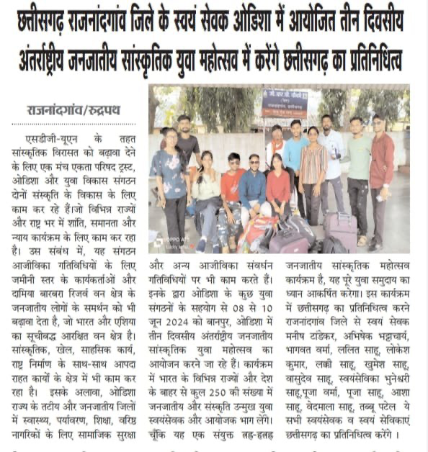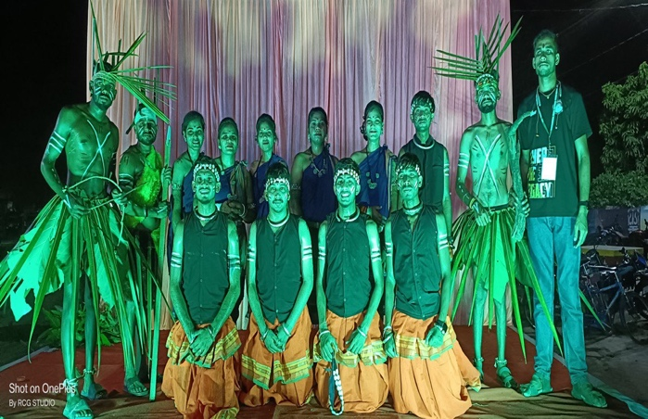

The national youth festival organised under the National Service Scheme ,was organised on 8th to 10th June 2024 at Odisha in which the talented students of Govt. Digvijay Autonomous PG, college, Rajnandgaon presented the rich cultural traditions of Chhattisgarh through their folk dance. The group that performed was constituted by the volunteers Manish, Abhishek, Vinay, Bhagvat, Khumesh, Lalit, Bhuvneshwari, Aasha, Pooja, Soniya and Pooja Verma.

